**Hi! I’m Mrs. Harrow Strickland**,

I am SO excited to be working with your fifth grader!! It’s going to be a year full of fun, learning, and creative experiences, and I can’t wait to see what the year has in store for us! I thought you might like to know a little about me.

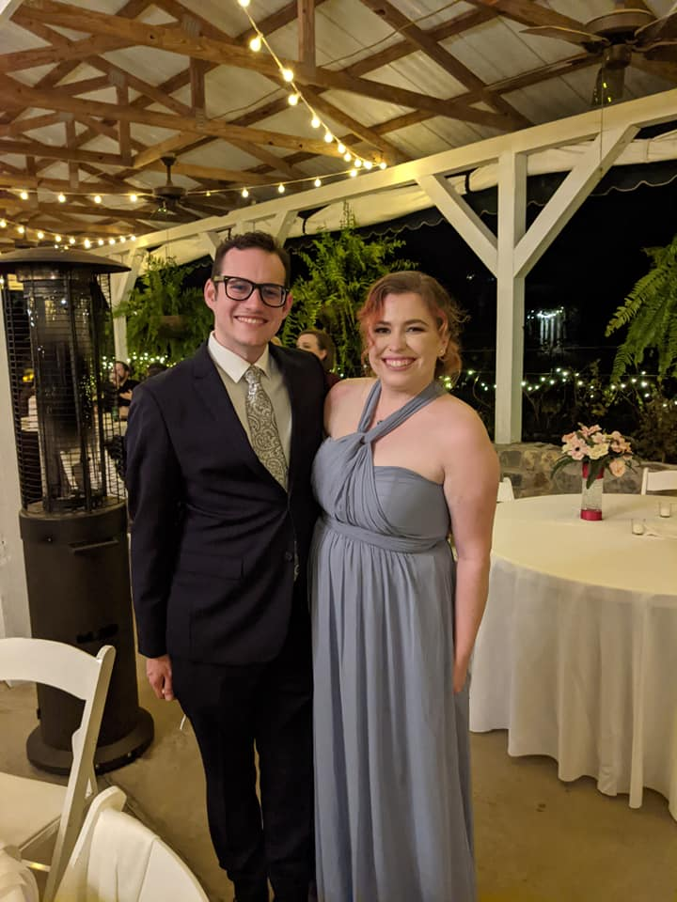

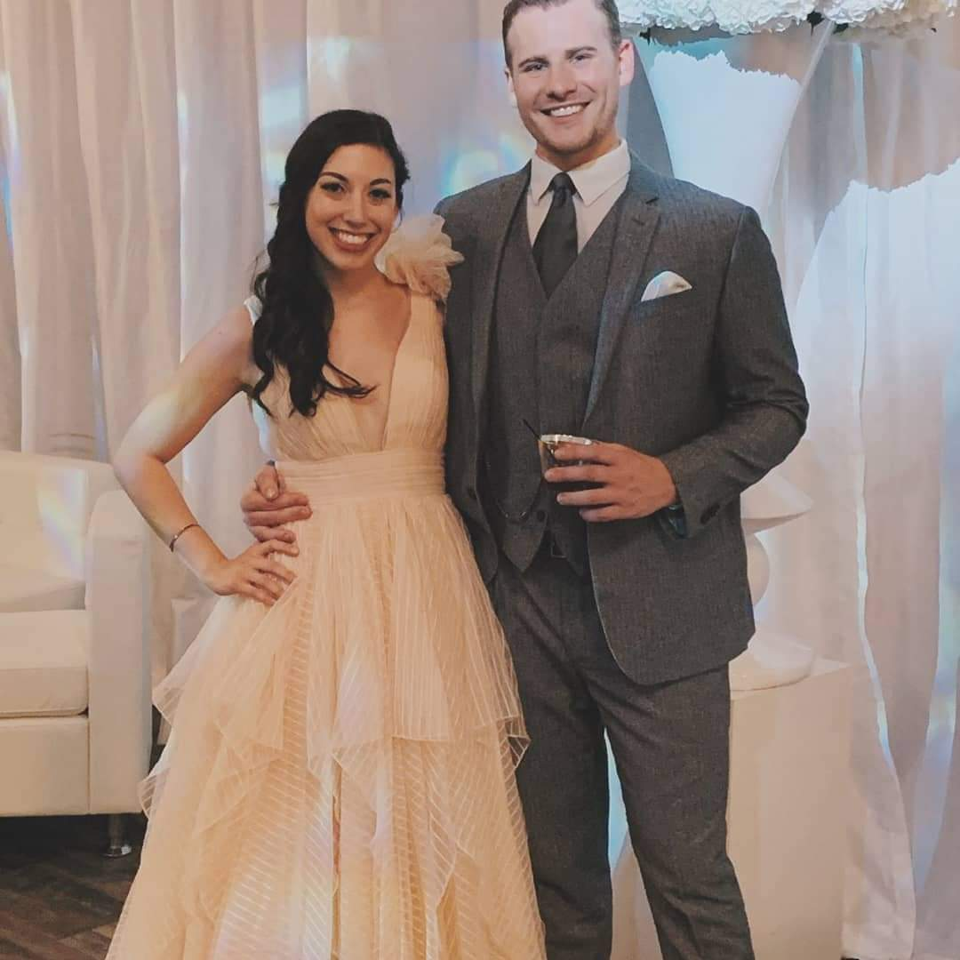I am married to my wonderful husband, Wayne, who works for AMSTI as the k-4 Online Class coordinator for the state. We live in Cary Woods and will celebrate 32 years together this September! We have two sons. Xan (29) graduated from AU and William & Mary with degrees in history and works at the Freedom Rides Museum in Montgomery. He is married to our sweet daughter-in-law, Cailin Kelley, who works for VCOM. They live in Auburn. Ben (27) graduated from AU with a degree in theater performance. He lives in Atlanta with his precious girlfriend, Valerie, and works as a theater tech with lighting and sound at the Alliance Theater.

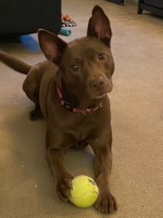

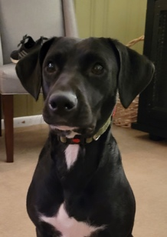We currently have two silly dogs! Tonks is a pit/shepherd rescue. We just celebrated her five-year “gotcha” day in July. She is the SWEETEST dog who loves to chase tennis balls and has the best ears! Bella is our lab mix that we adopted last July. Bella LOVES ALL TOYS!! She is the funniest, floppiest puppy.

I was born in Dothan, Alabama, came to Auburn University for school, and never left. I graduated from AUM in 1992 with my BS in Elementary Education. I received a MS in Elementary Ed. in 1994 and an MS in Library Media in 2000 from AU. In 2010 I obtained National Board Certification and renewed in 2020. I am an only child. My parents and in-laws still live in Dothan.

**A few of my favorites:**

Color: PURPLE!

Season: Fall

Food: Mediterranean (Italian & Greek)

Drink: COFFEE with oat-milk (because I’m lactose intolerant)

Song: “In My Life” by The Beatles

Book: Harry Potter series and so many more!

Sport: AU Football

This will be my 29th year teaching. Over the years I’ve mostly taught 5th grade with a few detours for 4th grade and Library Media. I absolutely love teaching fifth graders! It is my mission to instill a love of history, reading, and writing so that my students continue on their path to becoming life-long learners and engaged citizens. I’m looking forward to a great year together!

Mrs. Harrow Strickland

[hstrickland@auburnschools.org](mailto:hstrickland@auburnschools.org)

<https://www.linkedin.com/in/harrow-strickland-56864013/>